**DIGITAL LOGIC DESIGN CEP REPORT (CS-220)**

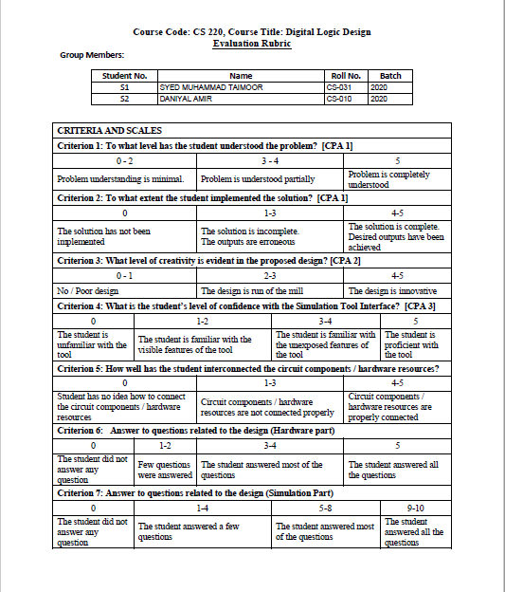

**Unlock Combination Pair Selected:**

As the 1st Roll No is 31 and the 2nd Roll No is 10, so 31+10=41. According to the Rule, as our least significant digit of 41 is 1, so the Unlock Combination Pairs are:

1. 1101

2. 0110

* In our project, we have used NO OVERLAPPING design.

**State Diagram:**

0/01

0/00 0/00 1/00

0/00 0/00 1/00 1/00

1/00

0/00 1/00 0/00

1/10

0/00

1/00

**State Assignment:**

No. of States = 7

No. of Flipflops needed = Log2N = Log27 = 3

So, 3 D-FFs will be needed for the design.

A = 000

B = 001

C = 010

D = 011

E = 100

F = 101

G = 110

**State Minimization:**

|  |  |
| --- | --- |
| 0 | 1 |
| A | B,00 | E,00 |
| B | A,00 | C,00 |
| C | A,00 | D,00 |
| D | A,01 | A,00 |
| E | A,00 | F,00 |
| F | G,00 | A,00 |
| G | A,00 | A,10 |

Pair Implication Chart:

D

E

F

G

C

B

|  |
| --- |
| A B  C E |
| A B  D E | C D |  | |
|  |  |  |
| A B  E F | C F | D F |  | |
| B G  A E | A G  A C | A G  A D |  | | A G  A F |
|  |  |  |  | |  |  |

F

D

B

E

C

A

* As no state is compatible to each other, so it is concluded that states will remain same.

**State Table:**

|  |  |  |  |  |  |  |  |  |  |  |  |
| --- | --- | --- | --- | --- | --- | --- | --- | --- | --- | --- | --- |
| Present State | | | Input | Next State | | | Output | | Flipflop Inputs | | |
| Q2(t) | Q1(t) | Q0(t) | X | Q2(t+1) | Q1(t+1) | Q0(t+1) | Y1 | Y0 | D2 | D1 | D0 |
| 0 | 0 | 0 | 0 | 0 | 0 | 1 | 0 | 0 | 0 | 0 | 1 |
| 0 | 0 | 0 | 1 | 1 | 0 | 0 | 0 | 0 | 1 | 0 | 0 |
| 0 | 0 | 1 | 0 | 0 | 0 | 0 | 0 | 0 | 0 | 0 | 0 |
| 0 | 0 | 1 | 1 | 0 | 1 | 0 | 0 | 0 | 0 | 1 | 0 |
| 0 | 1 | 0 | 0 | 0 | 0 | 0 | 0 | 0 | 0 | 0 | 0 |
| 0 | 1 | 0 | 1 | 0 | 1 | 1 | 0 | 0 | 0 | 1 | 1 |
| 0 | 1 | 1 | 0 | 0 | 0 | 0 | 0 | 1 | 0 | 0 | 0 |
| 0 | 1 | 1 | 1 | 0 | 0 | 0 | 0 | 0 | 0 | 0 | 0 |
| 1 | 0 | 0 | 0 | 0 | 0 | 0 | 0 | 0 | 0 | 0 | 0 |
| 1 | 0 | 0 | 1 | 1 | 0 | 1 | 0 | 0 | 1 | 0 | 1 |
| 1 | 0 | 1 | 0 | 1 | 1 | 0 | 0 | 0 | 1 | 1 | 0 |
| 1 | 0 | 1 | 1 | 0 | 0 | 0 | 0 | 0 | 0 | 0 | 0 |
| 1 | 1 | 0 | 0 | 0 | 0 | 0 | 0 | 0 | 0 | 0 | 0 |
| 1 | 1 | 0 | 1 | 0 | 0 | 0 | 0 | 1 | 0 | 0 | 0 |
| 1 | 1 | 1 | 0 | X | X | X | X | X | X | X | X |
| 1 | 1 | 1 | 1 | X | X | X | X | X | X | X | X |

**Deriving Equations:**

**D2** Q0 X

Q2 Q1 00 01 11 10

|  |  |  |  |
| --- | --- | --- | --- |
|  | 1 |  |  |
|  |  |  |  |
|  |  |  |  |
|  | 1 |  | 1 |

00

01

11

10

**D2 = Q1 ’Q0’ X + Q2 Q0 X’**

**D1** Q0 X

Q2 Q1 00 01 11 10

|  |  |  |  |
| --- | --- | --- | --- |
|  |  | 1 |  |
|  | 1 |  |  |
|  |  |  |  |
|  |  |  | 1 |

00

01

11

10

**D1 = Q2 Q0 X’ + Q2’ Q1 Q0’ X + Q2’ Q1’ Q0 X**

**D0** Q0 X

Q2 Q1 00 01 11 10

|  |  |  |  |
| --- | --- | --- | --- |
| 1 |  |  |  |
|  | 1 |  |  |
|  |  |  |  |
|  | 1 |  |  |

00

01

11

10

**D0 = Q2’ Q1’ Q0’ X’ + Q2’ Q1 Q0’ X + Q2 Q1’ Q0’ X**

**Y0** Q0 X

Q2 Q1 00 01 11 10

|  |  |  |  |
| --- | --- | --- | --- |
|  |  |  |  |
|  |  |  | 1 |
|  |  |  |  |
|  |  |  |  |

00

01

11

10

**Y0 = Q1 Q0 X’**

**Y1** Q0 X

Q2 Q1 00 01 11 10

|  |  |  |  |
| --- | --- | --- | --- |
|  |  |  |  |
|  |  |  |  |
|  | 1 |  |  |
|  |  |  |  |

00

01

11

10

**Y1 = Q2 Q1 X**

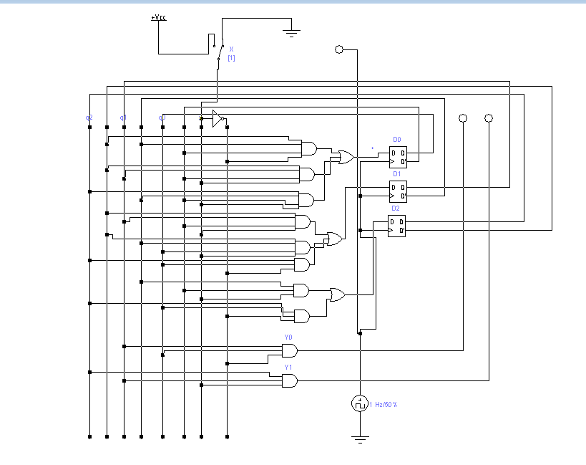**Circuit Diagram:**